Pack 3333 Newsletter

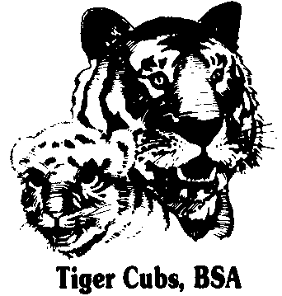


January 2008


Cub Scout Car Show

Den 4 Wolves in Charge
Meeting Agenda:
- Gathering Activity
  - PWD car show-off
- Opening Ceremony –
  - Present Colors
  - Pledge of Allegiance
  - Cub Scout Promise
- Activity – Bull’s Eye Race
- Announcements
- Awards Ceremony
- Cubmaster’s Minute
- Scout Vespers
- Retire Colors

Who Said This?
“The ultimate measure of a man is not where he stands in moments of comfort and convenience, but where he stands at times of challenge and controversy.”
“Darkness cannot drive out darkness; only light can do that. Hate cannot drive out hate; only love can do that. Hate multiplies hate, violence multiplies violence, and toughness multiplies toughness in a descending spiral of destruction…The chain reaction of evil-hate begetting hate, wars producing more wars-must be broken, or we shall be plunged into the dark abyss of annihilation.”
- Martin Luther King Jr.

Calendar of Upcoming Events

Fri. 2/8 – PWD Registration @ St. E’s
7-8:30 PM
Sat. 2/9 – PWD 9 AM-12 Noon
Thur. 2/21 – B&G Banquet @ St. E’s
6-8 PM
Sun. 2/24 – Scout Night @ Mad Ants
Sat. 3/1 – Miami District PWD
Sat. 3/8 – Scout Night @ Komets
Thur. 3/20 – March Pack Meeting @ D.R.
- Feller’s Cake Bake
- Uniform Inspection
Sat. 4/19 – Cubs-n-Motion
Vespers
{boys join hands crossed right over left & SING to tune of “Oh Christmas Tree!”}

Softly falls the light of day,
while our meeting ends today.
Silently each scout should ask:
“Have I done my daily task?
Have I kept my honor bright?
Can I guiltless sleep tonight?
Have I done and have I dared
everything to be prepared?”

WE ARE A PACK FAMILY
"Be involved"
Check out the PACK 3333 website at http://packs.scouter.com/in/Pack3333/. This site has our Calendars, Pack Activity Plan, Leader Roster, Scout Vespers, Info for new Cubs and other Useful Resource links, etc.

Cubscouting needs help from everyone to put on a great Scouting program!
Please volunteer to help with Den and Pack activities.
Please Contact Jim Krzyzanowski to volunteer!
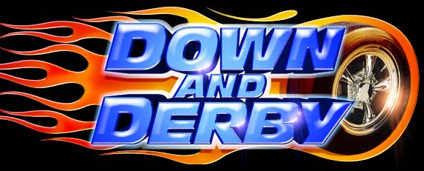
Pinewood Derby…

is Saturday February 9, 9 AM to 12 noon @ St. E’s (in the cafeteria). The PWD cars must be registered the night before any time from 7 to 8:30 PM.

Work on this project WITH your boys – remember the message of the Down & Derby movie @ the December Pack Meeting.

Bring the whole family to cheer on your boys and enjoy the fun & excitement of racing action.


Banquet…

is our February Pack Meeting. Thursday February 21, 6-8 PM @ St. E’s.

There will be pizza, pasta, salad, cake, drinks, & fun. Please RSVP by PWD.

The cost is $3 per person; 5 & under FREE. The whole family is welcome to attend.
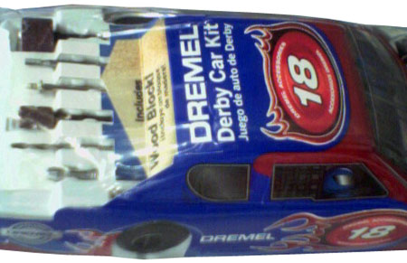
Lowe’s/Dremel PWD workshop…

every Tuesday @ 7 PM (Lima Rd).

How to build a car:
http://home.simplyweb.net/bosworth/howto.htm
Pictures:
http://home.comcast.net/~pack3333/pictures_2004_02_07.htm

