Pack 3333 Newsletter
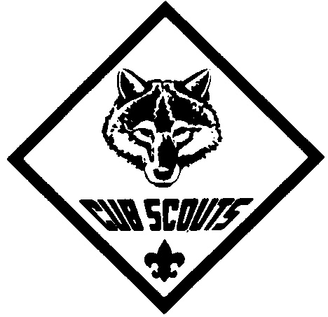
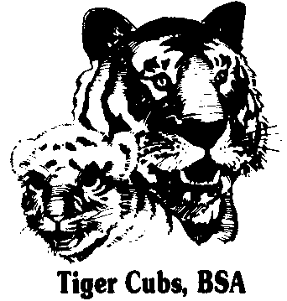
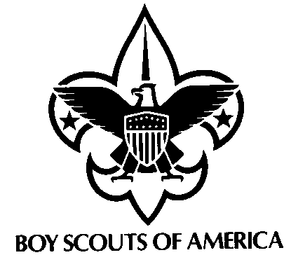

November 2007


Indian Nations

Den 1 Webelos in Charge
Meeting Agenda:
- Gathering Activity
  - Uniform Inspection
- Opening Ceremony –
  - Present Colors
  - Pledge of Allegiance
  - Cub Scout Promise
- Speaker
- Announcements
- Awards Ceremony
- Cubmaster’s Minute
- Scout Vespers
- Retire Colors
- Pie in the Face (outside)

The term "American Indian" incorporates hundreds of different tribes and approximately 250 languages. Starting in 1976 as Native American Awareness Week, the period was expanded by Congress and approved by President George Bush (41) in August 1990 by designating the month of November as National American Indian Heritage Month. In his proclamation for 1996, President Bill Clinton noted, "Throughout our history, American Indian and Alaska Native peoples have been an integral part of the American character. Against all odds, America's first peoples have endured, and they remain a vital cultural, political, social, and moral presence."

Calendar of Upcoming Events

Sat. 11/17 – Popcorn Pickup
Thur. 11/29 – Den Meetings
Fri. 11/30 – Tobogganing @ Pokagon
(6-10 PM); meet @ Scott & Illinois McD’s
- Popcorn Money Due
Wed. 12/5 – Round Table @ Waynedale UMC
(7-8:30 PM)
Thur. 12/6 – PLC Meeting @ St. E’s
(7-8:30 PM)
Thur. 12/13 – Den Meetings
Sat. 12/15 - Christmas Caroling @ Renaissance Village (6-7 PM)
Thur. 12/20 – Dec Pack Meeting @ Deer Ridge
- MOVIE NIGHT (come early) (6:30-8:30 PM)
Vespers
{boys join hands crossed right over left & SING to tune of “Oh Christmas Tree!”}

Softly falls the light of day,
while our meeting ends today.
Silently each scout should ask:
“Have I done my daily task?
Have I kept my honor bright?
Can I guiltless sleep tonight?
Have I done and have I dared
everything to be prepared?”

WE ARE A PACK FAMILY
"Be involved"
Check out the PACK 3333 website at http://packs.scouter.com/in/Pack3333/. This site has our Calendars, Pack Activity Plan, Leader Roster, Scout Vespers, Info for new Cubs and other Useful Resource links, etc.

Cubscouting needs help from everyone to put on a great Scouting program!
Please volunteer to help with Den and Pack activities.
Please Contact Jim Krzyzanowski to volunteer!
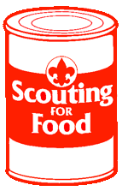 Food Service Project !!!

Tiger Den 8 will be delivering food to Harvest Food Bank on Saturday December 1st.

Please help by bringing food to the November Pack Meeting (11/15) or Tobogganing (11/30).


MOVIE NIGHT !!!

The December Pack Meeting (12/20) is @ Deer Ridge and this is our Movie Night. The meeting starts promptly at 6:30 PM.

There will be pizza, popcorn, & drinks.

We will also have a visit from a “special” guest.

The whole family is invited.
 Tobogganing @ Pokagon !!!

Friday November 30 – meet at Scott & Illinois McDonald’s by 6 PM.

The whole family is welcome - $2 per person.
- if driving, you’ll need $4 park entry

