Pack 3333 Newsletter
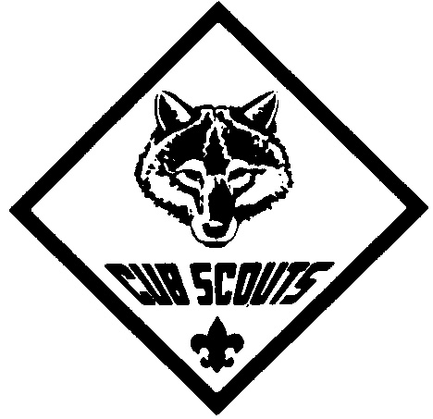

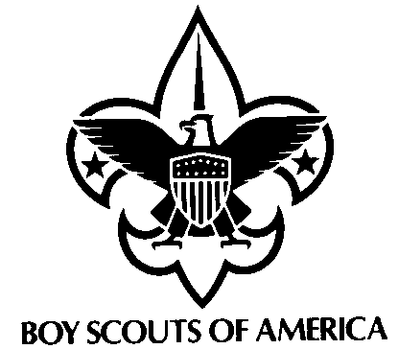

October 2007


Down on the Farm

Dens 5&6 Webelos in Charge
Meeting Agenda:
- Gathering Activity
- Opening Ceremony –
  - Present Colors
  - Pledge of Allegiance
  - Cub Scout Promise
- Activities
- Announcements
- Awards Ceremony
- Cubmaster’s Minute
- Scout Vespers
- Retire Colors

"A Scout is reverent." All Scouts show this by being faithful in their duty to God. Some go further and give special service. This can qualify them for a religious emblem. Such an emblem is not a Scouting award. It is conferred on a Scout by his religious leader. Each faith has its own requirements for earning its emblem.

Calendar of Upcoming Events

Sat. 10/20 – Haunted Forest @ Environmental Center
(6-8 PM)
Thur. 10/25 – Den Meetings
Sat. 10/27 – University of Scouting @ IPFW
- Popcorn Sale ENDS
Thur. 11/1 – Den Meetings
Wed. 11/7 – Round Table @ Waynedale UMC
(7-8:30 PM)
Thur. 11/8 – PLC Meeting @ St. E’s
(7-8:30 PM)
Thur. 11/15 – Nov Pack Meeting @ St. E’s
(7-8:30 PM) – UNIFORM INSPECTION
Thur. 11/29 – Den Meetings
Fri. 11/30 – Tobogganing @ Pokagon
(6-10 PM)
Vespers
{boys join hands crossed right over left & SING to tune of “Oh Christmas Tree!”}

Softly falls the light of day,
while our meeting ends today.
Silently each scout should ask:
“Have I done my daily task?
Have I kept my honor bright?
Can I guiltless sleep tonight?
Have I done and have I dared
everything to be prepared?”

POPCORN
Key Dates:

Saturday 10/27 – Sale ends
Make sure your Cub has selected a prize
Make a copy of the Take Order form.
Get your Take Order forms to your Den leader by this date.

Saturday 11/17 – Den Popcorn pick-up
Pick-up your Cub’s popcorn orders from your Den Leader
Distribute popcorn to your customers and collect all money due.

Thursday 11/29 – All money due to the Pack
Prior to this date your Den Leader will collect all checks and money from you

If you have any questions about Popcorn sales, please call Steve Conte at 625-4227
PARENTS: IMPORTANT NOTICE !!!

If your son has the Wolf/Bear Immediate Recognition totem that is worn on the shirt pocket, please bring it to your next Den Meeting or Pack Meeting. The company that distributes them has issued a voluntary recall due to higher than allowed traces of lead in the paint used on the totem.



WE ARE A PACK FAMILY
"Be involved"
Check out the PACK 3333 website at http://packs.scouter.com/in/Pack3333/. This site has our Calendars, Pack Activity Plan, Roster, Scout Vesper, Spirit Stick, Meeting Minutes and other Useful Resource links, etc.

Cubscouting needs help from everyone to put on a great Scouting program!
Please volunteer to help with Den and Pack activities.
Please Contact Jim Krzyzanowski to volunteer!
COMMUNITY ACTIVITIES !!!

Indiana History Train =>
Thur-Sat Oct. 18-20, 9 AM-6 PM
- behind FtW Newspapers
FREE
Salomon Farm Halloween Bash =>
Saturday Oct. 27, 4-7 PM
$2 per vehicle if ALL in costume

