Pack 3333 Newsletter
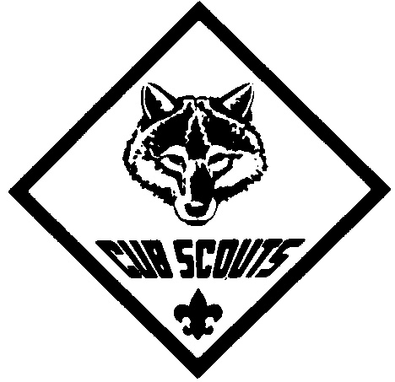



September 2007


Cub Scout Express

Den 3 Webelos in Charge
Meeting Agenda:
- Gathering Activity
- Opening Ceremony –
  - Present Colors
  - Pledge of Allegiance
  - Cub Scout Promise
- Introductions
- Activities
- Popcorn talk - Parents
- Popcorn Kernel - Cubs
- Awards Ceremony
- Announcements
- Cubmaster’s Minute
- Scout Vespers
- Retire Colors

Scouting is a Brotherhood -
With boys and girls from almost every country, religion, and race, Boy scouts is the largest world organization of its kind. In each Newsletter we will celebrate this strength by recognizing the contribution of our differences.

Calendar of Upcoming Events

Sat. 9/29 – Popcorn Blitz Day
Wed. 10/3 – Round Table @ Waynedale UMC
(7-8:30 PM)
Thur. 10/4 – PLC Meeting @ St. E’s
(7-8:30)
Sat. 10/6 – Zoo Day
Thur. 10/11 – Den Meetings
Fri-Sun. 10/12-10/14
– Fall Camporee @ IPFW
Thur. 10/18 – Oct Pack Meeting @ Deer Ridge
(7-8:30)
Sat. 10/20 – Haunted Forest @ Environmental Center
(6-8 PM)
Thur. 10/25 – Den Meetings
Sat. 10/27 – University of Scouting @ IPFW
- Popcorn Sale ENDS
Vespers
{Boys join hands crossed right over left & SING to tune of “Oh Christmas Tree!”}

Softly falls the light of day,
While our meeting ends today.
Silently each scout should ask:
“Have I done my daily task?
Have I kept my honor bright?
Can I guiltless sleep tonight?
Have I done and have I dared
Everything to be prepared?”

POPCORN
Key Dates:

Saturday 9/29 - Popcorn Blitz Day
Get your Popcorn sales Packet from your Den Leader.
Read the Packet carefully.
All checks are payable to Pack 3333.

Saturday 10/27 – Sale ends
Make sure your Cub has selected a prize.
Make a copy of the Take Order form.
Get your Take Order forms to your Den leader by 10/31.

Saturday 11/17 – Den Popcorn pick-up
Pick-up your Cub’s popcorn orders from your Den Leader.
Distribute popcorn to your customers and collect all money due.

Thursday 11/29 – All money due to the Pack
Prior to this date your Den Leader will collect all checks and money from you.

If you have any questions about Popcorn sales, please call Steve Conte at 625-4227


WE ARE A PACK FAMILY
"Be involved"
Cub Scouting needs help from everyone to put on a great Scouting program!
Please volunteer to help with Den and Pack activities.
Please Contact Jim Krzyzanowski to volunteer!

Check out the PACK 3333 website at http://packs.scouter.com/in/Pack3333/. This site has our Calendars, Pack Activity Plan, Roster, Scout Vesper, Spirit Stick, Meeting Minutes and other Useful Resource links, etc.

